Coursework Report

Errors and Fixes

Error 1:
The first error I encountered was that when the user would input a letter/ word for the menu screen, the program would error. This was because I had made the program accept integer values for the menu, and whilst the program would work for integers, when a letter was input, it would contradict the program logic therefore causing an error.
Shown below is the error that occurred when the string “a” was input:
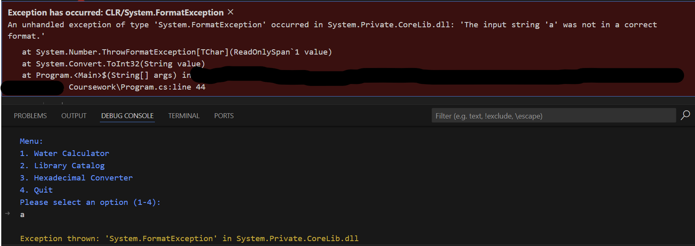
Below is the code that is responsible for the error:
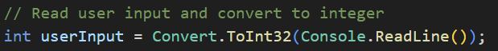

Fix 1
Below is the final code used to fix the problem:
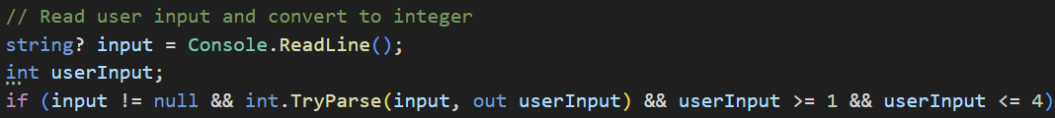
To fix the error I had the program first ask the user to input a string value into the console, however at first I had written: 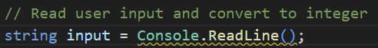 which doesn’t actually error but will cause the compiler to give a warning that the value null can be assigned to a string which cannot be assigned the value null, therefore, to combat this I added a “?” after the “string” data type to tell the compiler that the value of the string can be assigned null, which stops the compiler giving the warning.
I then created a new integer variable that is later used to store the parsed numeric value.
I then made the program do 3 validation checks to ensure that the user can only input an integer between 1 and 4. The first check is to make sure that the value of “input” is not null before attempting to parse it. The second check will attempt to convert the string value stored in “input” into an integer value and store it in the new previously declared variable “userInput”, if successful, it will return “true” and successfully assign the numerical value to the correct variable, if unsuccessful, it will return “false” and will set “userInput” to 0. And the final check in this line is ensuring that the integer value is between 1 and 4, if it is the program will call the corresponding method for the next stage of the program to occur, if the entered value is not between 1 and 4 then the program will prompt the user to enter a correct value and will repeat until done so.
Below is the fixed code being run when the string “a” is the input:
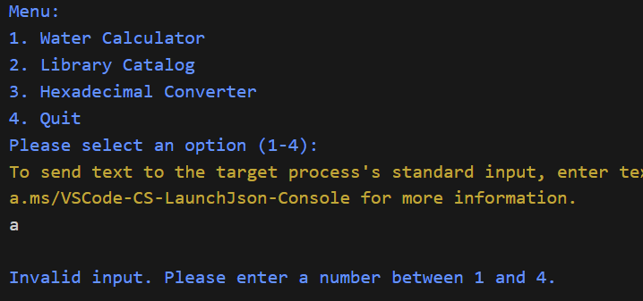

Error 2
The next error I encountered was in the Household Water Usage & Cost Calculator problem. The problem was that in the switch-case statement I created, which was responsible for deciding whether the user had entered a valid input/ appliance, would end once the default case was triggered, whereas I wanted the program to repeat until the user had successfully entered one of the correct appliances.
While the program would run without error, this is not the outcome that I desired, therefore I changed the code so that it would prompt the user to enter a correct appliance before moving on.
Below is the code responsible for that:
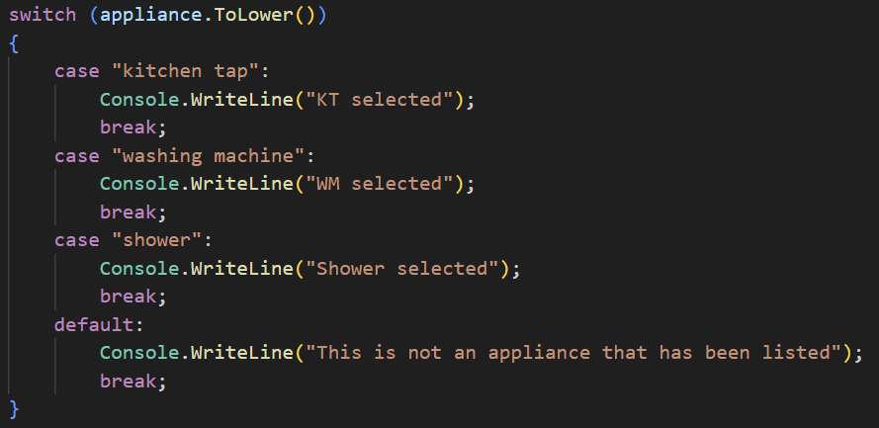
Below is what would occur in the terminal:
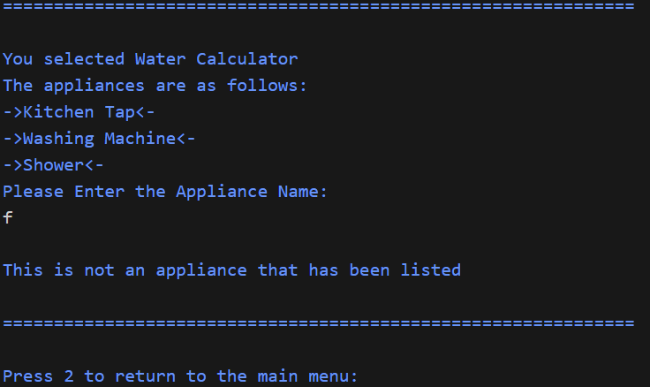
I first attempted to fix the problem by putting the switch case statement in a while loop that would repeat while a certain condition had not been met, below is the code that I first used:
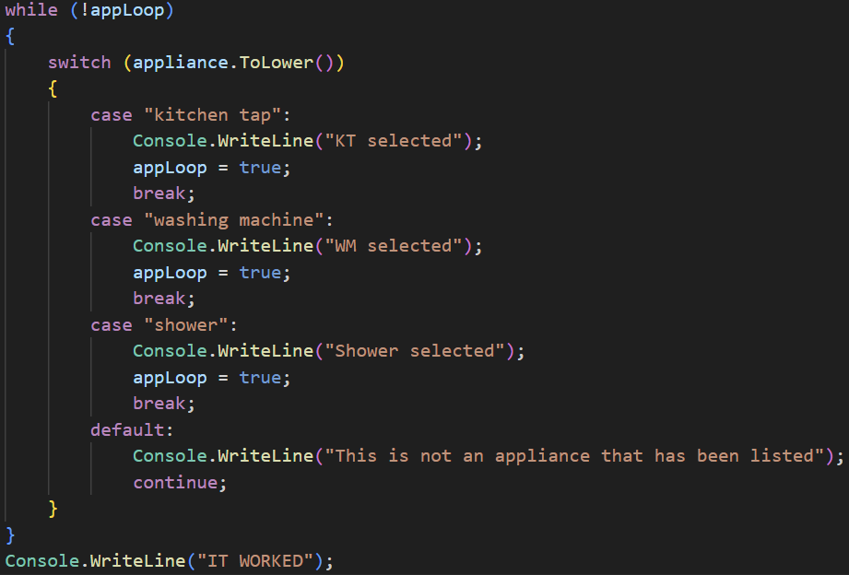
Whilst the code would run without error, when the user didn’t enter an appliance recognised by the switch case statement, the program would crash and not respond. This would’ve been because at the time there was no condition to break the while loop in the switch cases default statement despite the use of “continue” as the while loop was set to while not false instead of while true.
Proof of the program crashing after running:
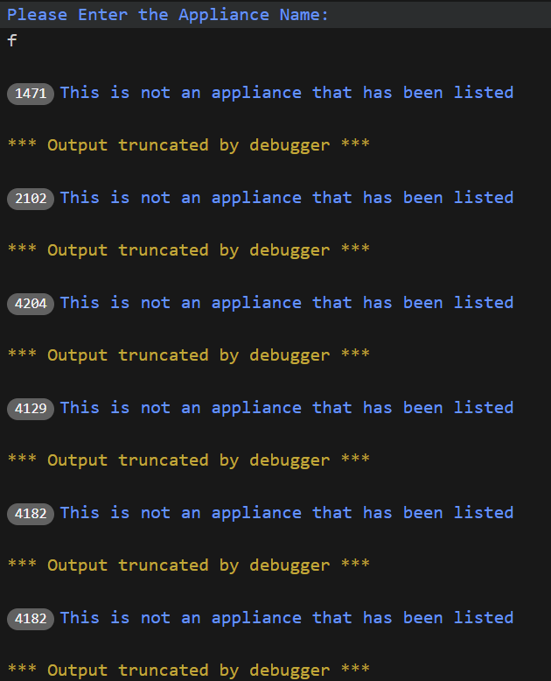

Fix 2
Below is the code used to fix the problem:
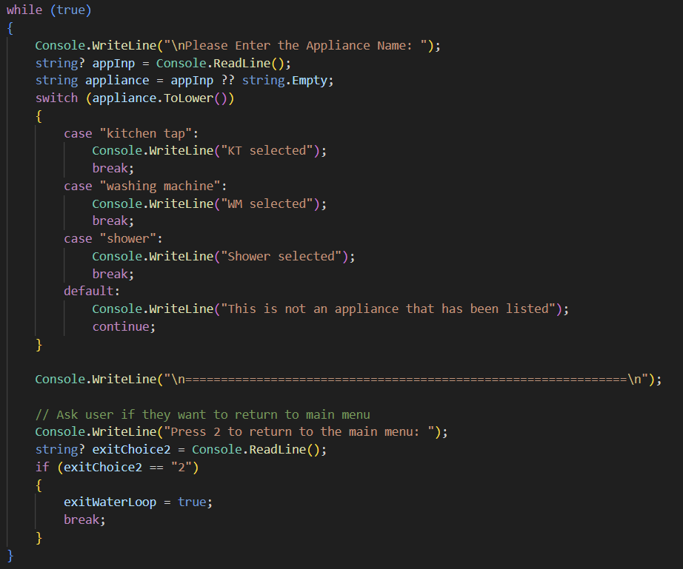
To fix this I first changed so that the while loop would repeat unless broken, this was done by changing the while loop to “while true”, I then changed it so that the program asks the user to input an appliance inside of the while loop rather than the outside so that the user is now given the opportunity to change their input. Then I changed it so that each of the cases would only break instead of setting the previous “appLoop” variable to true. And finally, I changed it so that after the user successfully enters an appliance, they are asked if they want to return to the main menu by entering the number 2, any other string or number that is input will result in the program asking for an appliance again.

Testing

Test Data for Problem 1 (Menu System)
Input Data | Expected Output | Actual Output
1 | User taken to Water Calculator program | As expected
2 | User taken to hexadecimal converter program | As expected
3 | User taken to Library Catalogue program | As expected
4 | Outputs message and program stops running | As expected
123456 | Message shown and user is prompted to input data again | As expected
Two | Message shown and user is prompted to input data again | As expected
- | Message shown and user is prompted to input data again | As expected
“ “ (Spacebar String) | Message shown and user is prompted to input data again | As expected

Test Data for Problem 2 (Water Calculator)
Input Data | Expected Output | Actual Output
Appliance name: Kitchen tap  Mode (1 = Litre/min, 2 = Litre/cycle): 1  Flow rate (Litre/min): 9  Minutes used per day: 10  Water price per 1000 L (£): 2.5 | Day usage: 90  Month Usage: 2700  Year Usage: 32850  Day Price: £0.22  Month Price: £6.75  Year Price: £82.12 | As expected
Appliance name: Washing Machine  Mode (1 = Litre/min, 2 = Litre/cycle): 1  Flow rate (Litre/min): 13  Minutes used per day: 5  Water price per 1000 L (£): 3.0 | Day usage: 65  Month Usage: 1950  Year Usage: 23725  Day Price: £0.2  Month Price: £5.85  Year Price: £71.18 | As expected
Appliance name: Shower  Mode (1 = Litre/min, 2 = Litre/cycle): 1  Flow rate (Litre/min): 5  Minutes used per day: 12  Water price per 1000 L (£): 2.99 | Day usage: 60  Month Usage: 1800  Year Usage: 21900  Day Price: £0.18  Month Price: £5.38  Year Price: £65.48 | As expected
Appliance name: Kitchen Tap  Mode (1 = Litre/min, 2 = Litre/cycle): 2  Flow rate (Litre/cycle): 50  Minutes used per day: 3  Water price per 1000 L (£): 2.5 | Day usage: 150  Month Usage: 4500  Year Usage: 54750  Day Price: £0.38  Month Price: £11.25  Year Price: £136.88 | As expected
Appliance name: Washing Machine  Mode (1 = Litre/min, 2 = Litre/cycle): 2  Flow rate (Litre/cycle): 21  Minutes used per day: 2  Water price per 1000 L (£): 1.5 | Day usage: 42  Month Usage: 1260  Year Usage: 15330  Day Price: £0.06  Month Price: £1.89  Year Price: £23 | As expected
Appliance name: Shower  Mode (1 = Litre/min, 2 = Litre/cycle): 2  Flow rate (Litre/cycle): 25  Minutes used per day: 1  Water price per 1000 L (£): 3.25 | Day usage: 25  Month Usage: 750  Year Usage: 9125  Day Price: £0.08  Month Price: £2.44  Year Price: £29.66 | As expected
Appliance Name: Dishwasher  Appliance Name: Kettle | User prompted to re-enter a valid appliance | As expected
Appliance Name: Shower  Mode (1 = Litre/min, 2 = Litre/cycle): 21, -1,  One | User prompted to enter either 1 or 2 | As expected
Appliance Name: Shower  Mode (1 = Litre/min, 2 = Litre/cycle): 1  Invalid Inputs: E.g. “four”, a, 5 + 5 | User prompted to re-enter a positive number | As expected
Appliance Name: Shower  Mode (1 = Litre/min, 2 = Litre/cycle): 1  Invalid Inputs: E.g. -3, -10, -21 | User prompted to re-enter a positive number | As expected

Test Data for Problem 3 (Library Catalogue)
Input Data | Expected Output | Actual Output
1 | User is prompted to add details of a book | As expected
2 | The showBooks method is called | As expected
3 | User is taken back to the main menu screen | As expected
Invalid inputs e.g. 4, a, 0 | User is prompted for a valid input | As expected
Book Type: Fiction  Book Genre: Fantasy  Book Title: How to Train Your Dragon  Book Author: Cressida Cowel | “Book Added Successfully!” String is output | As expected
Book Type: Non-Fiction  Book Genre: Biography  Book Title: The Diary of a Young Girl  Book Author: Anne Frank | “Book Added Successfully!” String is output | As expected
Book Type: f  Book Genre: Mystery  Book Title: The Hound of the Baskervilles  Book Author: Arthur Conan Doyle | “Book Added Successfully!” String is output | As expected
Book Type: n  Book Genre: Science  Book Title: A Brief History of Time  Book Author: Stephen Hawking | “Book Added Successfully!” String is output | As expected
Book Type: Gibberish  Book Genre: Everything  Book Title: Invalid Book Title  Book Author: The Ocean | “Invalid Input. Book not added” string is output | As expected
Book Type: fitcion  Book Genre: Adventure  Book Title: Treasure Island  Book Author: Robert Louis Stevenson | “Invalid Input. Book not added” string is output | As expected
Library Catalogue Menu Input: 2  Displaying Books Menu Input: 1  Book Genre: Fantasy | All books with the Genre “Fantasy” will have their title and author output | As expected
Library Catalogue Menu Input: 2  Displaying Books Menu Input: 1  Book Genre: Biography | All books with the Genre “Biography” will have their title and author output | As expected
Library Catalogue Menu Input: 2  Displaying Books Menu Input: 2 | All books in the List will have all their details output | As expected
Library Catalogue Menu Input: 2  Displaying Books Menu Input: 3, a, -107 | Error message prompts user for valid input | As expected

Test Data for Problem 4 (Hexadecimal Converter)
Input Data | Expected Output | Actual Output
21 | 15 | As expected
2 | 2 | As expected
8745 | 2229 | As expected
10990 | 2AEE | As expected
300 | 12C | As expected
0 | 0 | As expected
Invalid Inputs e.g. -10, abc | Error message prompts user to enter positive integer | As expected
2 (when asked to return to main menu) | Programs returns user to main menu screen | As expected

Report

Use of Iteration:
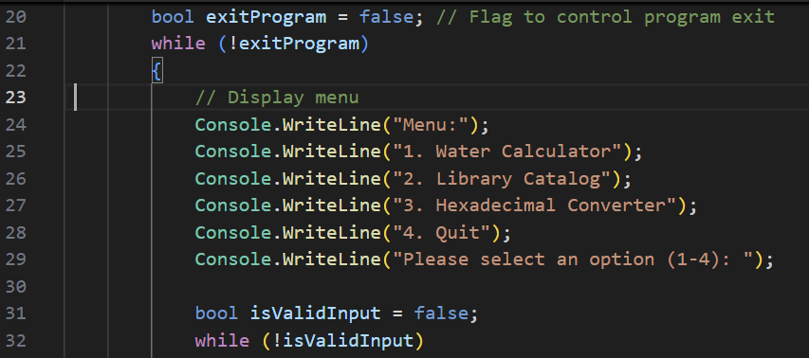
For my menu system I used 2 separate while loops, which can be seen in line 21 and 32, to control the actual running of the program as well as the user’s access to the other programs in the system. The first while loop will continue to execute the program until the user enters the integer 4 to tell the program to exit the loop.
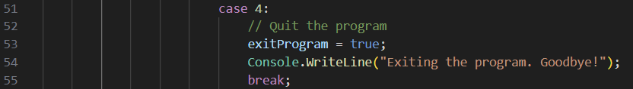
When the user enters the integer 4, the input is checked in a switch case statement so that the program can carry out the appropriate response, in this case when 4 is input, it will set the “exitProgram” variable to true which can be seen in line 53, meaning that the loop will stop repeating. After that the program will output a message confirming to the user that they have exited the program (seen in line 54) and finally the program will break out of the switch case statement.

Manipulation of Data Types:
The program will take an input of a string for the menu selection and will attempt to convert it to an integer while also checking that the value of the input is not Null and is an integer between 1 and 4. By using “int.TryParse” in line 37, the program will return a Boolean value if the conversion to an integer is successful, it also avoids exceptions which may stop the program from running, so if the conversion fails, the program will still run and the user will be prompted to enter a valid input.

How the Program Handles Problem Solving
For problem solving in the menu selection, there is an if statement to confirm whether or not the user’s input is valid, it will do this by checking different things (seen on line 37), it will first check whether the input is not Null, it will then attempt to convert the input into an integer, it will then check whether the input is greater than or equal to 1 as well as being less than or equal to 4, if all these conditions are met the program will then move onto the switch case statement which follows the comment on line 39. However, even one of these conditions are not met, the program will jump to the else statement on line 60 to output the message on line 62 and the user will be able to re-enter a number due to still being inside of the while loop on line 32.

Error Handling
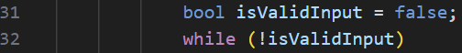
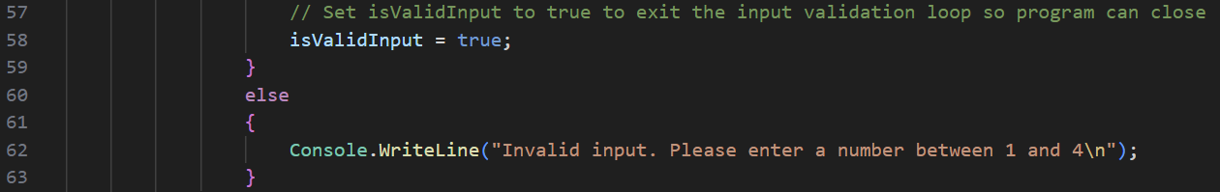
For the error handling in the menu system, I made it so that there is a while loop which will continue to repeat the value of “isValidInput” is false. The value of this Boolean variable will change (seen on line 58) once all the conditions in the if statement on line 37 are met, if the conditions are not met due to the user entering an invalid input, the error message on line 62 will be output and the user will be able to re-enter a value to continue the program.

